# Master Thesis Proposal Tobias Grundmann

Topic: **Artificial Intelligence (with a focus on Machine Learning) for Innovation in Companies**

Artificial Intelligence is deemed the third digital revolution, fourth industrial revolution (industry 4.0) or with the augmented age the fifth age of mankind (https://www.youtube.com/watch?v=aR5N2Jl8k14&t=20s). It is thus a major game changer in the ways we work and will massively influence our business in the years to come (Andrew Ng quote about AI till 2040). However, while the technical side has built up a strong academic track record, the business side is still in the phase of exploration through companies and management science hasn't even awoken (graph about number of AI publications in management journals). To enable a successful spread of this technology we need to connect the demands and pains from the business with the technical possibilities of research, to be able to draw a state of the current capabilities and a roadmap on how this technology should develop. This thesis will draw on modern content clustering algorithms to analyze business publications on the one side and technical academic publications on the other side and try to match needs and capabilities. Thereafter in interview sessions with experts and leaders from the industry we will try to establish a roadmap to building a successful connection between business and academia.

## Hypothesis

1. There are different requirements and values in different machine learning approaches

## Outcome

1. A map of machine learning algorithms, applications & requirements
2. Roadmap to the business success of AI

## Process

1. Latent Dirichlet Allocation on top of the major machine learning publications, corporate (MCK, BCG, BAIN, MIT Tech Review, …) publications and major digitalization publications.
2. Explorative Analysis through Interviews with Experts and Company Representatives.

Roadmap

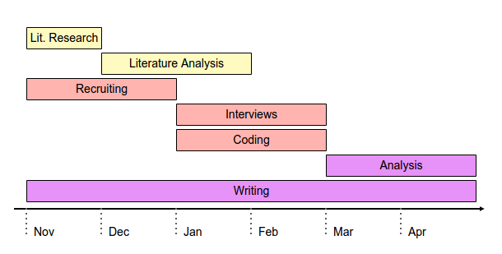

# Master Thesis Proposal 2

Capabilities based view of AI requirements

… unlike the previous revolutions where companies could create requirements to implement the new achievements (some source digitalisation), deep learning does set requirements on those who want to transform through the technology. While every revolution is constrained by the ability of humans adopt the changes that are brought by the revolution, this revolution requires companies to plan for the revolution.

Hypothesis:

1. For a company to be able to gain value from artificial intelligence in general and machine learning in special, the need to be AI ready. AI readiness consist of:
   1. the mind set to understand the requirements of machine learning (processes that collect training data)
   2. Processes that create, collect and manage training data
   3. Subject matter expertise paired with data science knowledge to model
   4. Infrastructure to compute
   5. The ability to adopt and implement the change

Outcome

1. AI readiness framework